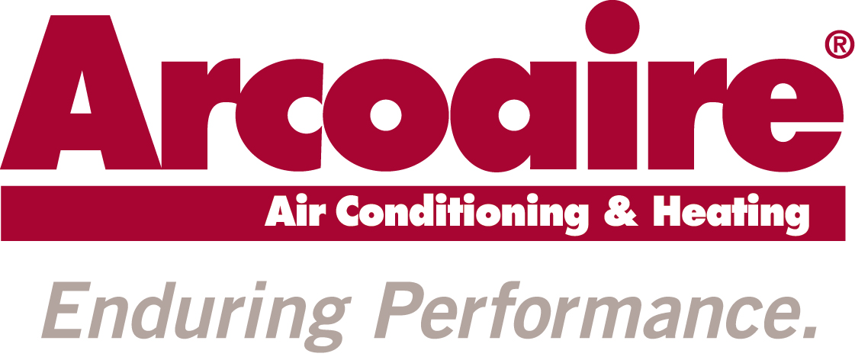
RADIO SCRIPT
JOB NUMBER: 16-ICP-0033
DATE: 7/6/16

Heating Season Radio -- :23 Radio Script / :07 Dealer Tag

Arcoaire Product Excellence:

V/O:
Arcoaire heating systems are built rugged so you stay comfortable all winter long. They’re also designed with convenience in mind when paired with our Observer communicating control with Wi-Fi capability that lets you remotely adjust your home comfort settings. Call [Dealer Name] today to discover how Arcoaire heating systems deliver the rock-solid performance you deserve, even in the toughest winter weather. Designed to tackle winter’s worst. Arcoaire.

Call (555) 123-4567 or find us online at ABCHVAC.com. Arcoaire. Enduring Performance.

Arcoaire Dealer Quality:

V/O:
[Dealer name] is ready for any challenge winter throws our way. Whether you need a fall tune-up to get ready for freezin’ season or a mid-winter emergency repair call, we’ll do our very best to keep you comfortable. Arcoaire is the name to remember for rugged heating products and the reliable service that keeps you toasty all winter long. We’re just as tough as winter. Arcoaire.

Call (555) 123-4567 or find us online at ABCHVAC.com. Arcoaire. Enduring Performance.

Arcoaire Service:

V/O:
Before winter gets brutal, make sure your heating system is up to the challenge. [Dealer name] can perform a timely fall tune-up that might even help lower your winter heating bills. Call us today and we’ll make sure your system performs its best when winter gets tough. Arcoaire heating systems and reliable service from your local dealer. We’ll get you ready for a rugged winter.

Call (555) 123-4567 or find us online at ABCHVAC.com. Arcoaire. Enduring Performance.

